

**Web Technologies**

**DIT 2083**

**Web Application Name:**

Aeolian Symphonies

**Student Name and ID:**

Chan Jia Yee D19050004

**Lecturer Name:**

Prof. Nor Adnan Yahaya

**Word Count:**

Table of Contents

1. Overview of the Web Application 4

1.1 Introduction 4

1.2. The Completed Web Application 4

2. Wireframes 8

3. Composing the Audio 9

3.1 The Software 9

3.2 The Composing Process 9

4. Building the Web Application 11

4.1 The Overall Themes 11

4.1.1 The Home Page 11

4.1.2 Seafarer 11

4.1.3 CyberNoir 11

4.1.4 Autumn Wind 11

4.2 The Navigation Bar 12

4.2.1 The HTML 12

4.2.2 The CSS 12

4.3 The Heading and Descriptions 14

4.3.1 The HTML 14

4.3.2 The CSS 15

4.4 The ‘Play/Pause’ Button 16

4.4.1 The HTML 16

4.4.2 The CSS 17

4.4.3 The JavaScript 18

4.5 Track Volume Sliders 20

4.5.1 The HTML 20

4.5.2 The CSS 20

4.5.3 The JavaScript 21

4.6 Randomize 22

4.6.1 The HTML 22

4.6.2 The CSS 22

4.6.3 The JavaScript 23

4.7 Random Song 24

4.7.1 The HTML 24

4.7.2 The CSS 24

4.7.3 The JavaScript 25

5. Conclusion 26

# 1. Overview of the Web Application

## 1.1 Introduction

Aeolian Symphonies is an experimental web application which aims to provide users with a new and interesting listening experience. It features three original compositions which have been created specifically for this website, namely Seafarer, CyberNoir, and Autumn Wind, along with their respective cover art. Each instrument within these tracks have been separated individually to allow users to interact with them.

## 1.2. The Completed Web Application

The completed web application features four pages in total: one homepage and a page for each composition. The web application has been tested and confirmed to work on the latest versions of Firefox, Google Chrome, and Microsoft Edge. The web application has also been tested on Internet Explorer (which is no longer supported by Microsoft), and although it is indeed functional, the volume sliders seem to break and thus this browser is not recommended.

The web application has been coded with responsive design in mind, and thus should fit just about any modern device screen. Each page has a unique theme appropriate to the audio tracks, completed with unique font and design choices. Screenshots of the webpages will be shown in the following pages.

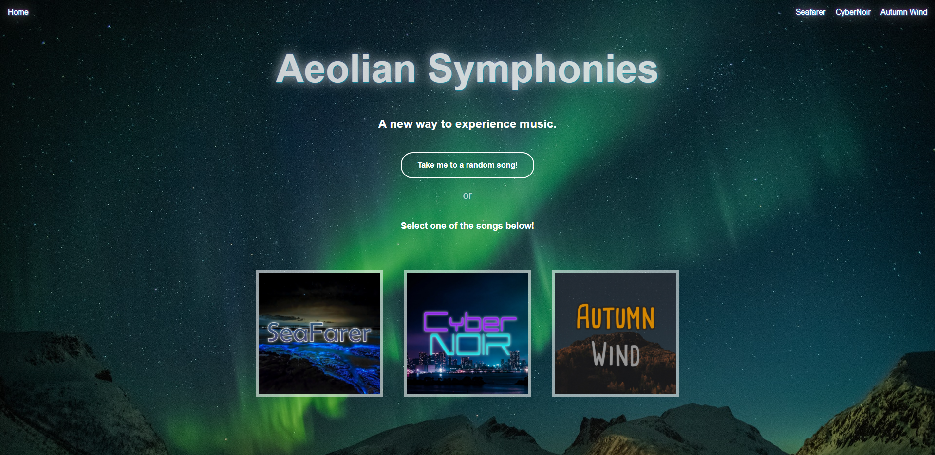

**Figure 1.2.1: The Homepage**

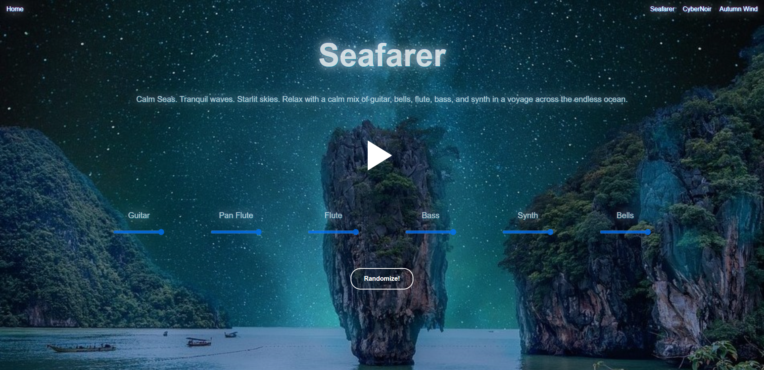

**Figure 1.2.2: The Page for Seafarer**

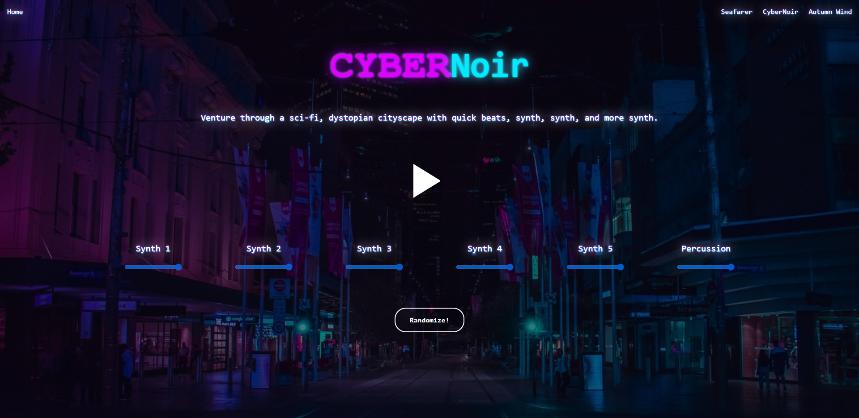

**Figure 1.2.3: The Page for CyberNoir**

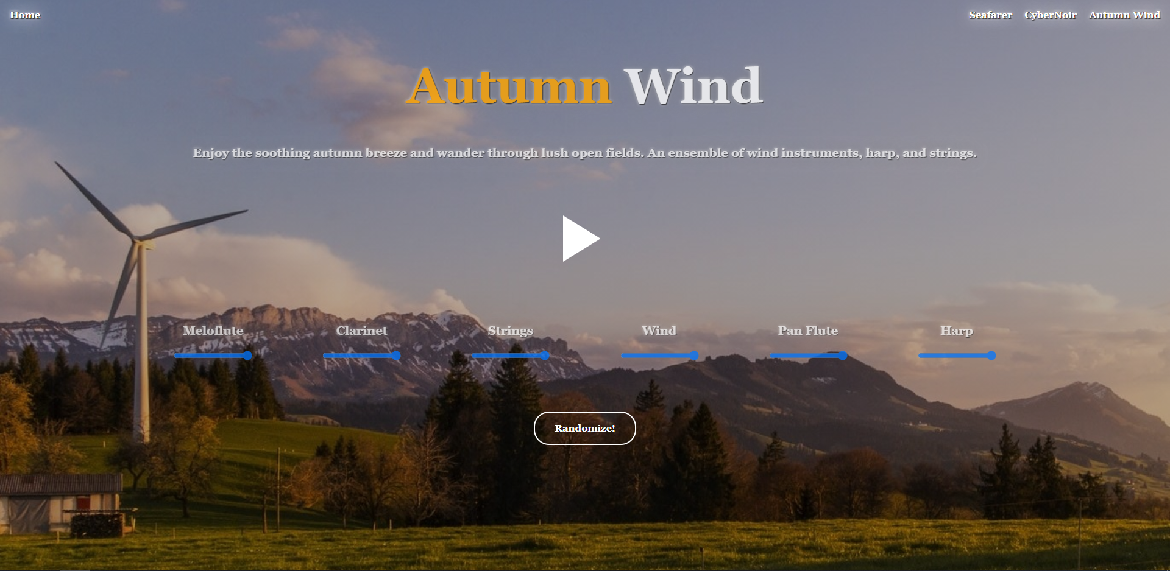

**Figure 1.2.4: The Page for Autumn Wind**

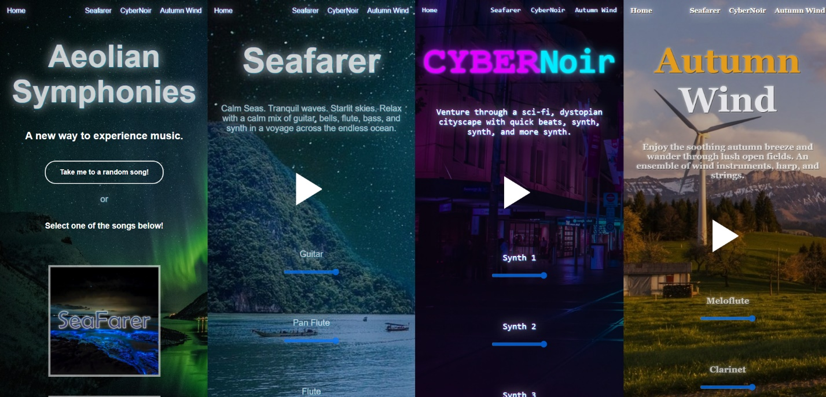

**Figure 1.2.5: Showcasing the Responsive Design of Each Page**

# 2. Wireframes

The website itself is designed with simplicity in mind, thus a minimalist design has been utilized to make the web application appear clean and modern. The following wireframes have been created using Pencil during the initial stages of the project, where the songs have yet to be composed, thus filler text has been used to plan the overall design of the webpages.

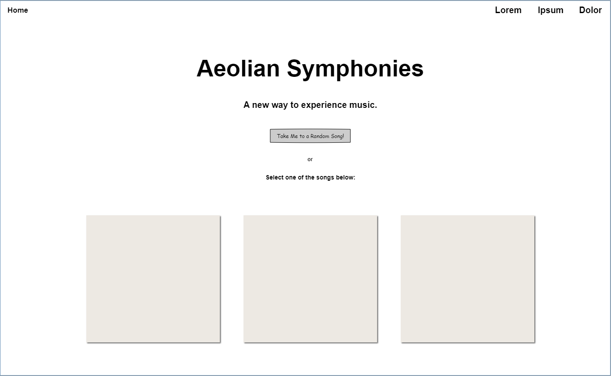

**Figure 1.2.1: Wireframe of the Homepage**

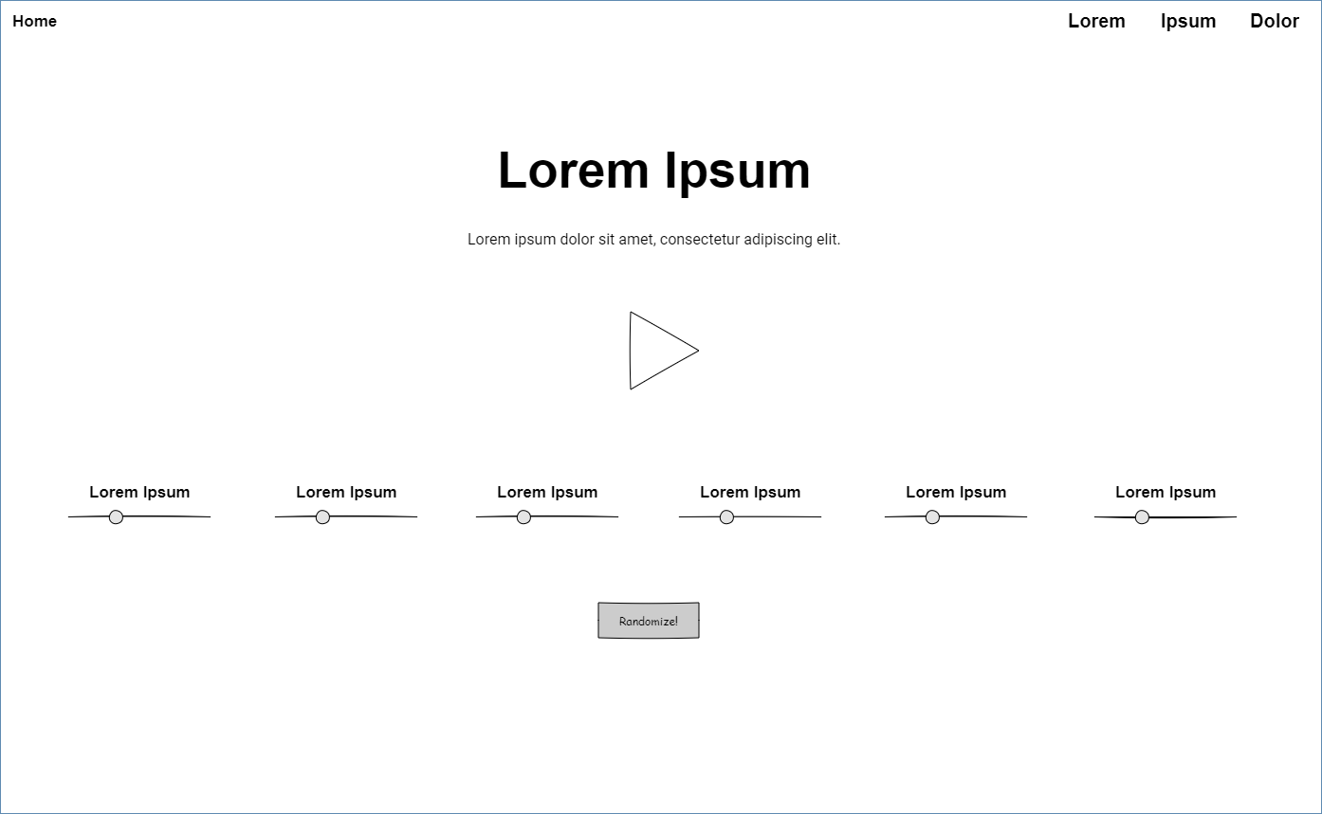

**Figure 1.2.2: Wireframe of Individual Track Pages**

# 3. Composing the Audio

## 3.1 The Software

The audio tracks featured within this web application have been composed using Fruity Loops Studio. Below is an image of the interface when composing the audio track ‘Autumn Wind’.

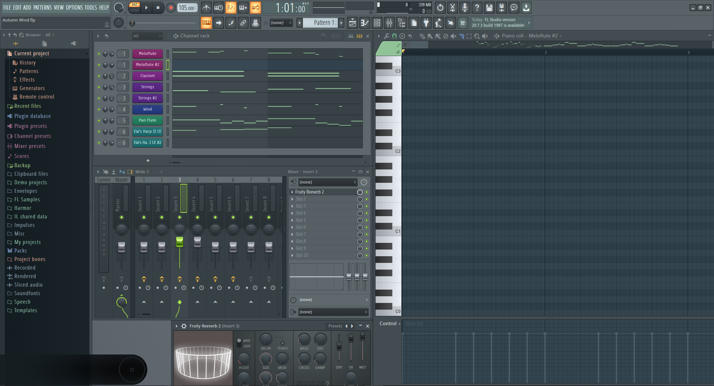

**Figure 3.1.1: Composing Autumn Wind**

## 3.2 The Composing Process

Before composing, I’ve picked out a different theme for each audio track, then selected the appropriate instruments, time signature, and beats per minute. For Seafarer, I’ve decided upon a soothing atmosphere which reflects calm seas; for CyberNoir, fast-paced synth which depicts a sci-fi city; and for Autumn Wind, a melody featuring mostly woodwind instruments which is lively yet relaxing.

As each instrument track can be directly manipulated through the application, I’ve taken great care to ensure that every instrument is playing throughout the entire audio track, while still keeping the audio track itself relatively interesting. Below is an example of the instrumental track for the bells in Seafarer.

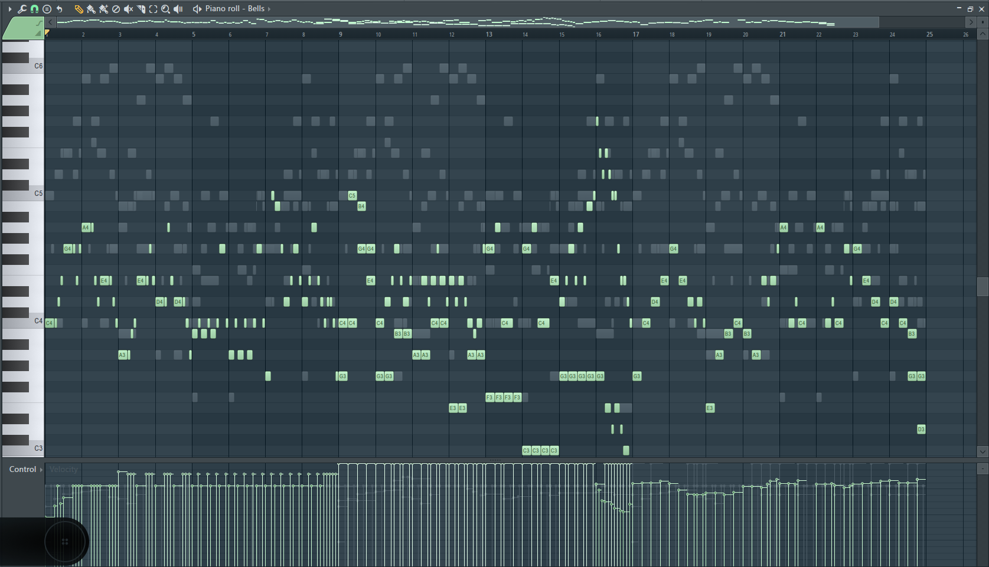

**Figure 3.2.1: Composing the Bell Section for Seafarer**

Once all of the instrument tracks are ready, the tracks are then exported individually into .wav files (the software does not support directly exporting individual tracks for .mp3 and .ogg files). Next, the audio files are converted into both .mp3 format and .ogg format in order to ensure cross-browser compatibility (certain browsers, such as Firefox, do not support .mp3 files). The audio files are then ready to use for the web application project.

# 4. Building the Web Application

To keep this report clean and tidy, I have decided to leave out most of the source code due to its repetitive nature across similar web pages. The code which I find more interesting will be explained in detail in the following pages. Helpful comments will also be scattered throughout the source code.

## 4.1 The Overall Themes

I’ve decided to create a different theme for each page according to its music track. As each page has its unique theme, it should only be fitting that each page has a color scheme tailored to its theme as well, along with the appropriate typography. All background images are obtained from pexels.com, which provides free stock images with no need for attribution.

### 4.1.1 The Home Page

For the home page, I’ve chosen a modern and neutral look. An image of aurora borealis has been chosen as the background due to its natural color gradient and unobtrusiveness. Arial is selected as the font for this page as it has a clean and contemporary look.

### 4.1.2 Seafarer

For Seafarer, I’ve decided to go with a mythical, fantasy theme, and thus a background image of tall rock sculptures over a calm ocean and a galaxy full of stars is selected. Arial is chosen as the default font as I find the font to have a calming effect. A glow effect has been added to the text.

### 4.1.3 CyberNoir

For CyberNoir, I went with a neon, cyberpunk theme, and thus selected an image of a busy city alley at night for the background. Monospace has been chosen as the font for this page as it is reminiscent of neon alley lights. A glow effect similar to neon lights has been added to the text.

### 4.1.4 Autumn Wind

For Autumn Wind, I’ve decided that I wanted a cozy, countryside theme, and thus went with a background image of an autumn sunset in open fields. I went with Georgia as the font for this page as I find the serif font to convey an “old-timey” feeling.

## 4.2 The Navigation Bar

The navigation bar is located on the very top of each webpage to allow the user to easily switch between pages. It links to all four pages of the web application.

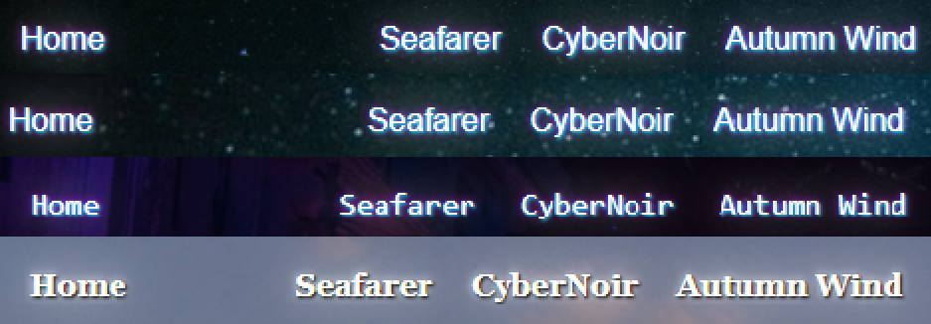

**Figure 4.2.1: Navigation Bars**

### 4.2.1 The HTML

The HTML for the navigation bar is fairly straightforward. It consists of several elements within an unordered list which links to the respective pages.

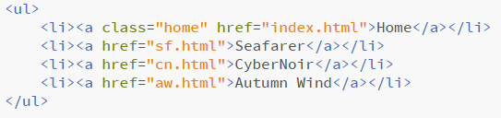

**Figure 4.2.2: HTML Code for the Navigation Bars**

### 4.2.2 The CSS

The CSS defines the style for the navigational bar. Besides adjusting the padding and margins, the bullets from the unordered list have been removed, as shown in the following code snippet. Different glow effects are added for different pages. For a better user experience, the text will glow brighter when the cursor hovers over it. The ‘Home’ button is made to float to the left to separate it from the other buttons.

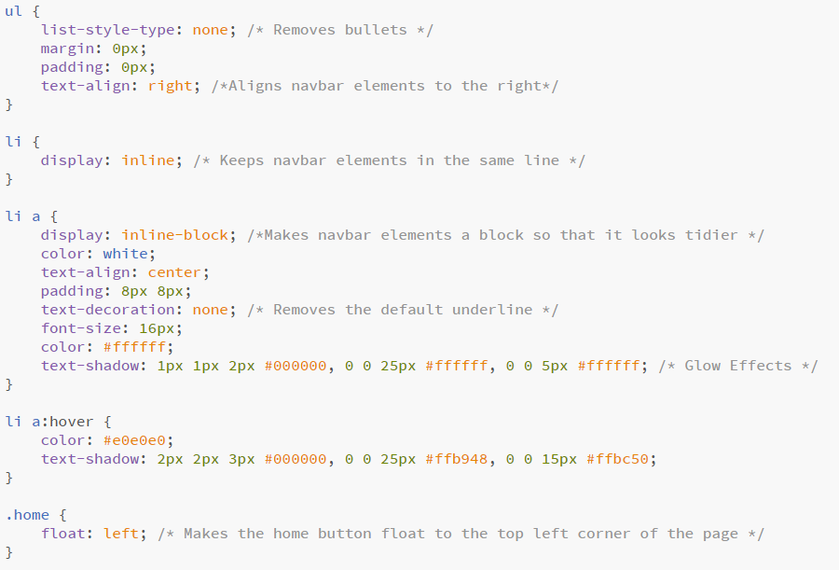

**Figure 4.2.3: CSS Code Snippet for the Navigation Bar of Autumn Wind**

## 4.3 The Heading and Descriptions

Each page has a main heading and descriptions to provide the user with more information regarding the page.

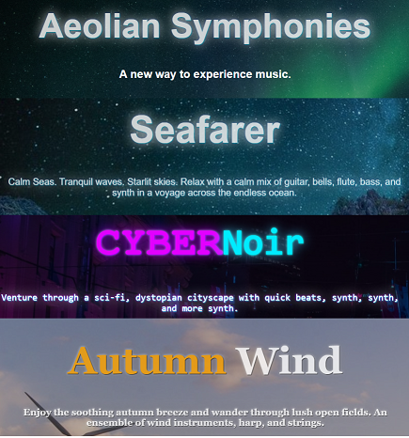

**Figure 4.3.1: Headings and Descriptions**

### 4.3.1 The HTML

The HTML code for the title and description of CyberNoir is shown below. Other pages use a similar structure, although a span may not be used if the header only has a single color.

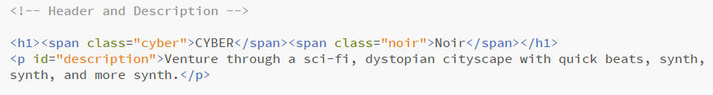

**Figure 4.3.2: HTML Code for the Header and Description of CyberNoir**

### 4.3.2 The CSS

The CSS for the header and description of CyberNoir is shown below. A glowing neon effect is achieved using the ‘text shadow’ property. Two span elements each with a class attribute are used to separate the header into two distinct colors.

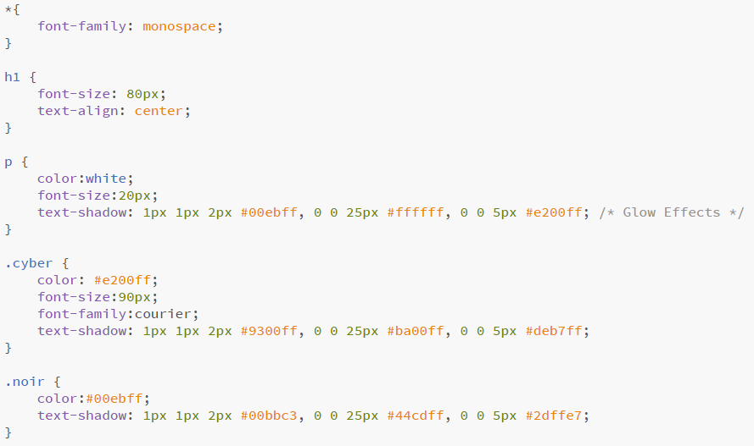

**Figure 4.3.3: CSS Code for the Header and Description of CyberNoir**

## 4.4 The ‘Play/Pause’ Button

Pages which contain audio will also contain a button which either plays or pauses the audio, depending if the audio is currently playing. The icon of the button will change accordingly.

When the audio is not playing, the ‘play’ symbol will be displayed to let users know that clicking the button will play the audio. Similarly, when the audio is playing, the ‘pause’ symbol will be displayed to let users know that clicking the button will pause the audio.



**Figure 4.4.1: Icon when Audio is Not Playing**



**Figure 4.4.2: Icon when Audio is Playing**

### 4.4.1 The HTML

The HTML code for the Play/Pause button as well as the code for linking the audio sources are shown below. The play() function is executed once the button has been clicked. The audio files are set to loop and will play indefinitely until it is paused or the user leaves the page.

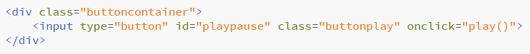

**Figure 4.4.3: HTML Code for Play/Pause Button**

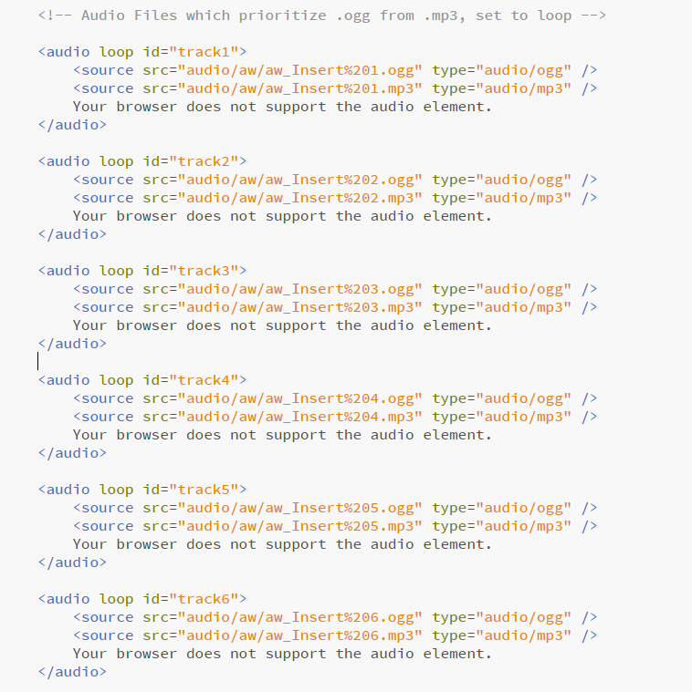

**Figure 4.4.4: HTML Code for Linking the Audio Tracks**

### 4.4.2 The CSS

The icons of the play/pause button are created from pure CSS using a ‘border trick’ instead of using image icons. I’ve written the following code with guidance from an online website, although some work has been done to convert the code from SCSS to CSS, and additional JavaScript code has been added to change the icon based on the state of the music tracks.

The website link is: https://css-tricks.com/making-pure-css-playpause-button/

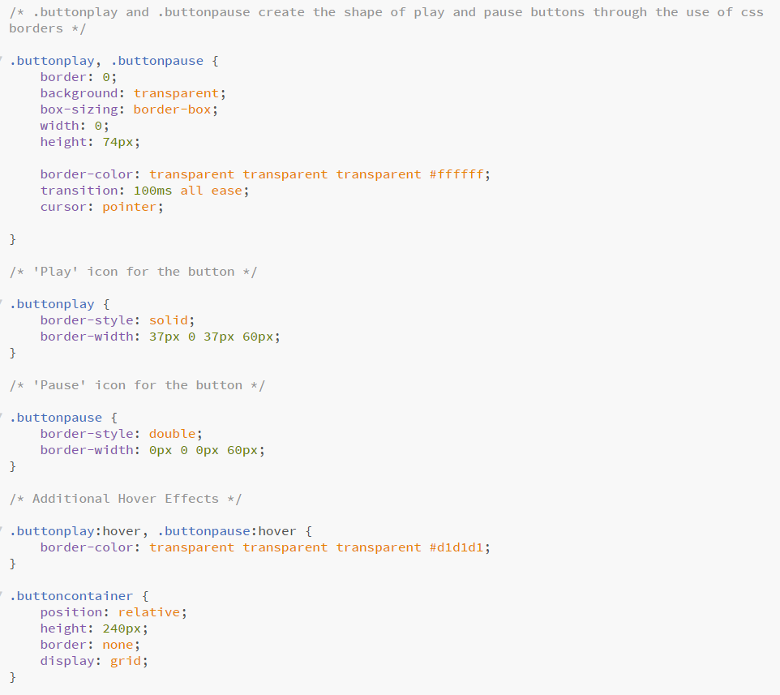

**Figure 4.4.5: CSS for the Play/Pause Button**

### 4.4.3 The JavaScript

JavaScript has been used to play or pause all audio tracks within a webpage when the Play/Pause button is clicked. All web pages with audio use the same script file, which is music.js. Although all songs ended up having 6 instrumental tracks, the code is able to support songs from anywhere between 1 to 10 tracks, and the upper limit can be increased. Furthermore, the function changes the appearance of the Play/Pause button by changing its class. The code for the Play/Pause button will be shown below.

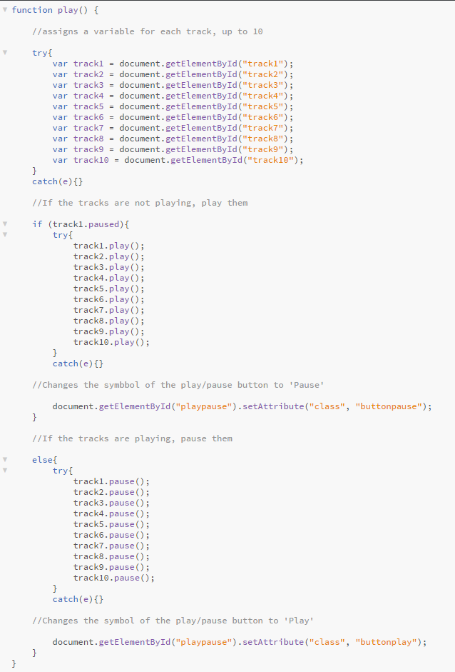

**Figure 4.4.6: JavaScript for the Play/Pause Button**

## 4.5 Track Volume Sliders

Each instrumental track for a song will have its own volume slider, allowing users to try out various instrument combinations at varying volumes. As each instrumental track within a song has the same length as the others, they should play in unison even after the tracks loop.

### 4.5.1 The HTML

A div container is used for a slider and label pair, and all the slider containers are put into a larger div container in order to create a tidier interface. The HTML code for the volume sliders are as follows. The volume() function is executed when the sliders are interacted with.

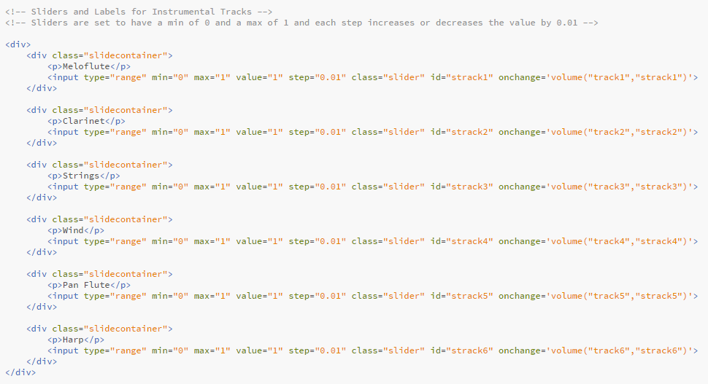

**Figure 4.5.1: HTML for Track Volume Sliders**

### 4.5.2 The CSS

Inline -block is selected for the display property so sliders will position themselves according to the size of the browser window. The CSS for track volume sliders is as follows.

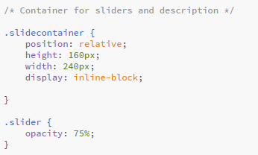

**Figure 4.5.2: CSS for Track Volume Sliders**

### 4.5.3 The JavaScript

The JavaScript code for changing the volume based on the sliders is as follows:

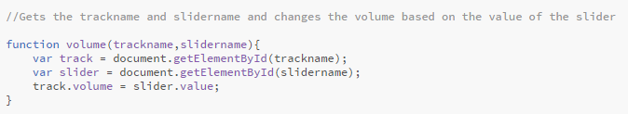

**Figure 4.5.3: JavaScript Code for Changing Volume based on Sliders**

## 4.6 Randomize

The Randomize button will set the volume of individual instrumental tracks to a random value, creating a different combination of instrumental tracks each time the button is pressed.



**Figure 4.6.1: The Randomize Button**

### 4.6.1 The HTML

The HTML for the Randomize button is as follows:

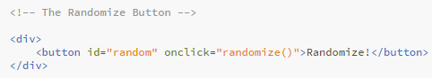

**Figure 4.6.2: HTML for the Randomize Button**

### 4.6.2 The CSS

The CSS for the Randomize button is as follows:

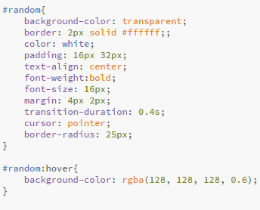

**Figure 4.6.3: CSS for the Randomize Button**

### 4.6.3 The JavaScript

Similar to the play() function, the randomize() function supports up to 10 tracks, but the upper limit can be increased. The JavaScript for the Randomize button is as follows:

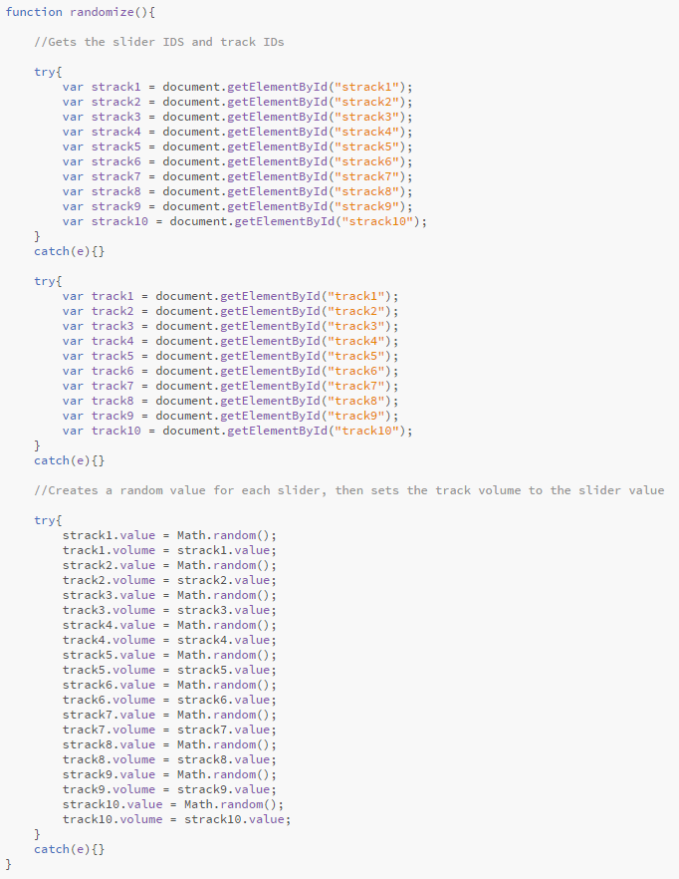

**Figure 4.6.4: JavaScript for the Randomize Button**

## 4.7 Random Song

The ‘Take me to a random song!” button is located on the home page. It will direct the user to a random song by executing the randompage() function on click.



**Figure 4.7.1: The ‘Take me to a random song!’ Button**

### 4.7.1 The HTML

The HTML for the Random Song button is as follows:

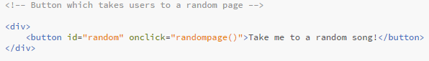

**Figure 4.7.2: HTML for the Random Song Button**

### 4.7.2 The CSS

The CSS for the Random Song button is as follows:



**Figure 4.6.3: CSS for the Random Song Button**

### 4.7.3 The JavaScript

The JavaScript for the Random Song button is as follows:

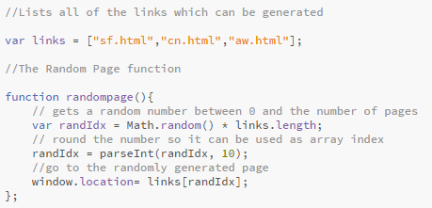

**Figure 4.6.4: JavaScript for the Randomize Button**

# 5. Conclusion

In conclusion, Aeolian Symphonies is an experimental web application which utilizes HTML, CSS, and JavaScript to allow users to manipulate audio and enjoy a unique audio experience. I’ve thoroughly enjoyed creating this project and have learned quite a lot from the creation process. I genuinely hope that its users will find the web application as fun and entertaining as I do, or at least view it as a rather amusing audio experience.